

Quentin

BOOKKEEPING web APPLICATION

Romesh Etulgama (2016521460535)

| Capstone Project |

Under supervision of Mr. Li Chuan

Software Collage - SICHUAN UNIVERSITY

26-04-2020

# Abstract

This report describes the project development of the Bookkeeping web application, "Quentin" that was developed to manage the daily transactions and manage the clients, inventories, sales and accounts more efficiently. This application is mainly used by the clerks, managers and the CEO of the company. A clerk is able to manage the suppliers, inventories, production, sales and financial transactions in the company as well as the factory itself. Besides that, the application allows the user to generate various kinds of reports such as client information, historical reports plus reliable forecasts to help the entrepreneurs make better decisions.

The methodology I used to develop this system is waterfall model. Thus, the report's chapters include system planning, requirement analysis, system design, programming, system testing, and evolution of the project. For the system planning, the outcomes are the project objectives and project aim as well as to define the project scope. Requirement analysis is a stage to gather the user requirements such as functional requirements and non-functional requirements. Next the system design is mainly used to design the user interface and the database design. The next stage after system design is programming stage. This is the stage for coding. After completion of the coding part, I proceeded to the system testing to minimize the bugs in the systems.

Compared to the existing manual methods used by the target company, this system has many strengths and fairly small amount of weaknesses such as requirement of general computer literacy. In the future, we can enhance the system with smart technologies to make it better.

Keywords: Bookkeeping, Accounting, Management, Small Businesses,

# Acknowledgements

After completing my capstone project, I would like to take this chance to express my sincere gratitude to my project supervisor Mr. Li Chuan who has guided me a lot throughout the project development.

Lorem ipsum dolor sit amet, consectetuer adipiscing elit. Maecenas porttitor congue massa. Fusce posuere, magna sed pulvinar ultricies, purus lectus malesuada libero, sit amet commodo magna eros quis urna. Nunc viverra imperdiet enim. Fusce est. Vivamus a tellus. Pellentesque habitant morbi tristique senectus et netus et malesuada fames ac turpis egestas. Proin pharetra nonummy pede.

Mauris et orci. Aenean nec lorem. In porttitor. Donec laoreet nonummy augue. Suspendisse dui purus, scelerisque at, vulputate vitae, pretium mattis, nunc. Mauris eget neque at sem venenatis eleifend. Ut nonummy. Fusce aliquet pede non pede.

Suspendisse dapibus lorem pellentesque magna. Integer nulla. Donec blandit feugiat ligula. Donec hendrerit, felis et imperdiet euismod, purus ipsum pretium metus, in lacinia nulla nisl eget sapien. Donec ut est in lectus consequat consequat. Etiam eget dui. Aliquam erat volutpat. Sed at lorem in nunc porta tristique.

Proin nec augue. Quisque aliquam tempor magna. Pellentesque habitant morbi tristique senectus et netus et malesuada fames ac turpis egestas. Nunc ac magna. Maecenas odio dolor, vulputate vel, auctor ac, accumsan id, felis. Pellentesque cursus sagittis felis. Pellentesque porttitor, velit lacinia egestas auctor, diam eros tempus arcu, nec vulputate augue magna vel risus. Cras non magna vel ante adipiscing rhoncus.

# Table of contents

Chapter 1

**System Planning**

# System Planning

The development process of the system will be discussed in this chapter as well as the system objectives, scope and schedules.

## 1.1 Project Aims and Objectives

The project aims and objectives that will be achieved after completion of the system are discussed here. The succession of the system will also be evaluated through this sub chapter.

The project objectives are:

* To eliminate/reduce the paper work in the company
* To record every transaction in computerized system so that problems occur by human error can be greatly reduced
* To implement smart technologies to the system
* To design a user-friendly graphical user interface which suits the users
* To complete the system according to the project schedule
* To produce technical reports that documents the phases, tasks and deliverables in the project

## 1.2 Background of the project

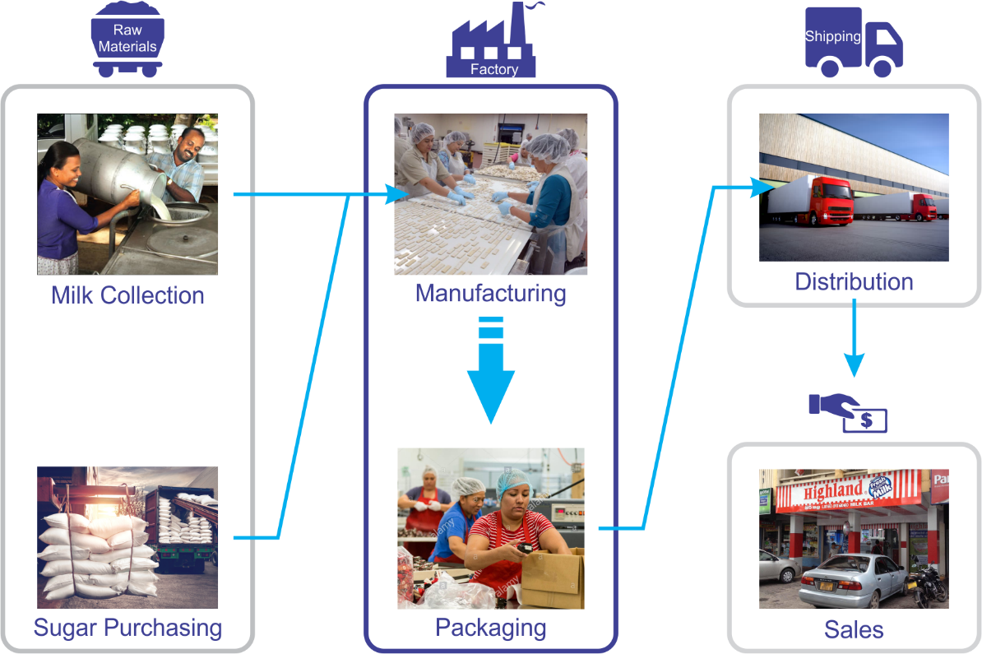"Quentin" is a management system developed geared mainly toward small and medium-sized businesses and offer cloud-based accounting and management applications that handle the primary bookkeeping functions of a company and manage payments and payroll functions, manage asset collections, track distribution, manage relationships with their clients and more importantly to make predictions on sales.

Figure 1 : Company Workflow

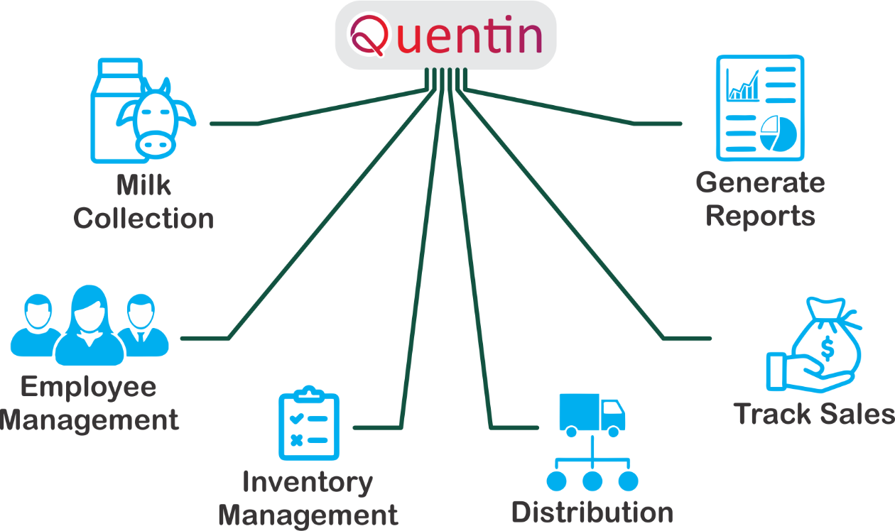This application is mainly used by the clerks, managers and the CEO of the company. A clerk is able to manage the suppliers, inventories, production, sales and financial transactions in the company as well as the factory itself. Besides that, the application allows the user to generate various kinds of reports such as client information, historical reports plus reliable forecasts to help the entrepreneurs make better business decisions.

Figure 2 : Tasks handled by Quentin

Since all of the calculations, report generation and the ability to check real-time status makes the work of the users much easier narrowing down the entirety of their workload into just recording the correct data.

## 1.3 Project Scope

The modules contained inside the bookkeeping application will be discussed below.

For the "Quentin" system, it has a web application as the front-end user interface while the back-end of the system takes care of the data validation and database management on the server.

The modules can be divided into some categories as they serve for each purpose within the system.

Milk Collection –

Employee Management –

Inventory Management –

Distribution –

Sales Tracking –

Report Generation –